SIMATS ENGINEERING
ASSESSMENT TOOL 1

COURSE NAME: Artificial Intelligence COURSE CODE: CSA17

COURSE OUTCOME COVERED

CO1: Apply AI basics such as intelligent agents and uninformed search methods to solve problems effectively. (BL3)

Assessment Tool Weightage: 50%

QUESTIONS: 5 Duration : 1 Hour

Total Marks:50

Annexure A

Analytical Problem Solving

Code of Conduct:

I P.Deenadayalan /(192521135) (Name / Reg No) certify that this submission is my original work and that I have adhered to the guidelines specified for this assessment.
I understand that any violation of academic integrity rules will result in disciplinary action.

Signature of the student:
DEENADAYALAN

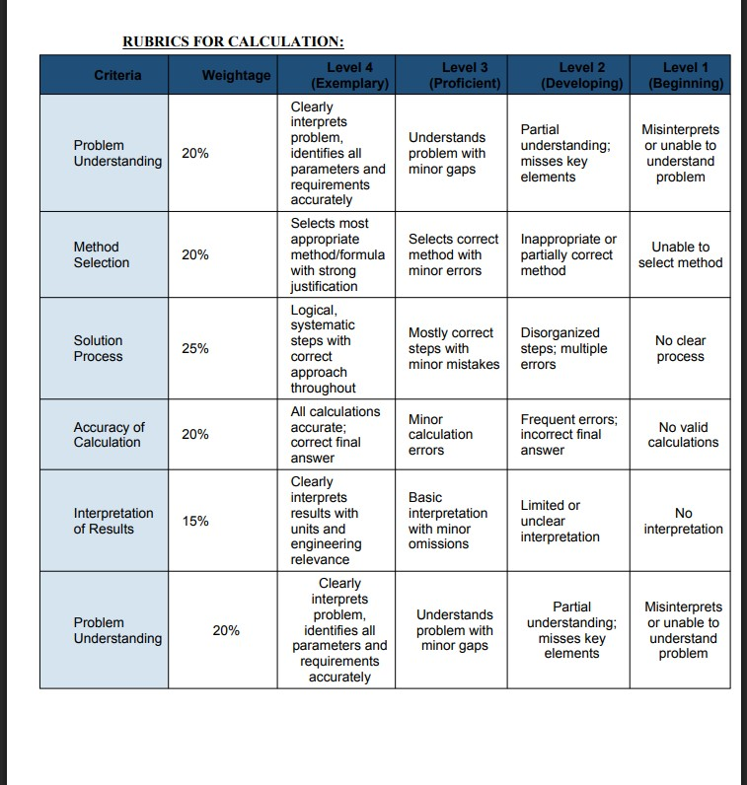

1. Solve the Water Jug problem: you are given 2 jugs, a 4-gallon one and 3-gallon one. Neither has any measuring maker on it. There is a pump that can be used to fill the jugs with water. How can you get exactly 2 gallons of water into 4-gallon jug? Explicit assumptions: A jug can be filled from the pump, water can be poured out of a jug onto the ground, water can be poured from one jug to another and that there are no other measuring devices available.

Algorithm
- Start with both jugs empty (0,0).
- Fill the 3-gallon jug.
- Pour it into the 4-gallon jug.
- Fill the 3-gallon jug again.
- Pour from the 3-gallon jug into the 4-gallon jug until the 4-gallon jug is full. This leaves 2 gallons in the 3-gallon jug.
- Empty the 4-gallon jug.
- Pour the remaining 2 gallons from the 3-gallon jug into the 4-gallon jug.
- Stop when the 4-gallon jug contains exactly 2 gallons.

State Space Representation :-
Step | 4-Gallon  Jug | 3-Gallon  Jug | Action
1 | 0 | 0 | Initial State
2 | 0 | 3 | Fill 3-gallon jug
3 | 3 | 0 | Pour into 4-gallon jug
4 | 3 | 3 | Fill 3-gallon jug again
5 | 4 | 2 | Pour into 4-gallon jug until full
6 | 0 | 2 | Empty 4-gallon jug
7 | 2 | 0 | Pour remaining water into 4gallon jug

Solution
Initially both jugs are empty. Fill the 3-gallon jug and pour it into the 4-gallon jug. Fill the 3gallon jug again and pour water into the 4-gallon jug until it becomes full. This leaves exactly 2 gallons in the 3-gallon jug. Empty the 4-gallon jug and pour the remaining 2 gallons into it.
Final Answer: The 4-gallon jug contains exactly 2 gallons.

2. Find out how Mars Rover, analyse and explore the samples on Mars by answering the following questions. What are the percept’s for this agent? ii. Characterize the operating environment. iii. What are the actions the agent can take? iv. How can one evaluate the performance of the agent? v. What sort of agent architecture do you think is most suitable for this agent? Why?
i) What are the percepts for this agent?
Percepts are the inputs received by the Mars Rover through its sensors.
- Camera images
- Rock and soil composition
- Temperature
- Atmospheric pressure
- Terrain information
- Obstacle detection
- Position and location
- Battery level ii) Characterize the operating environment
Characteristic | Description
Observability | Partially Observable
Deterministic | Stochastic (Uncertain)
Episodic/Sequential | Sequential
Static/Dynamic | Dynamic
Discrete/Continuous | Continuous
Single/Multi Agent | Single Agent
iii) What are the actions the agent can take?
- Move forward
- Move backward
- Turn left/right
- Capture images
- Drill rocks
- Collect soil samples
- Analyze samples
- Send data to Earth
- Avoid obstacles iv) How can one evaluate the performance of the agent?
The performance is evaluated based on:
- Accuracy of sample collection
- Safe navigation
- Obstacle avoidance
- Efficient battery usage
- Successful communication with Earth
- Completion of mission objectives
v) What type of agent architecture is suitable? Why?
Learning Agent is the most suitable architecture.
Reason:
- Learns from previous experiences.
- Adapts to unknown environments.
- Improves navigation over time.
- Makes better decisions in uncertain situations.
- Suitable for autonomous exploration.

3. Explore the search space using search strategies and formulate the problem components for the 8-Queens problem using the following information: Place 8 queens on a chessboard such that none of the queen’s attack any of the others. A configuration of 8 queens on the board as shown in the figure below, but this does not represent a solution as the queen in the first column is on the same diagonal as the queen in the last column.
Problem Formulation
Place 8 queens on an 8 × 8 chessboard such that no two queens attack each other.
Problem Components
Initial State
An empty chessboard.
State Space
All possible arrangements of queens on the chessboard.

Operators
- Place a queen in a safe position.
- Move to the next row.
Goal State
Eight queens are placed without attacking each other.

Goal Test
No two queens share:
- Same row
- Same column
- Same diagonal
Path Cost
Each move has equal cost.
Search Strategy
The Backtracking Search Algorithm is used.

Algorithm
- Start from the first row.
- Place a queen in a safe column.
- Check whether the position is safe.
- If safe, place the queen.
- Move to the next row.
- If no safe position exists, backtrack.
- Continue until all 8 queens are placed.

4. A customer wants to travel from the one location to another location using OLA Cab booking mobile application. The customer can select the any of the cab type as mini, micro, sedan, shared, prime and so on based on his comfort to reach the destination. Identify what type of problem-solving agent can be used and write the pseudocode for the above problem.
Type of Problem-Solving Agent
Goal-Based Agent

Reason
A goal-based agent chooses actions based on the customer's goal of reaching the destination safely and efficiently.
The agent evaluates:
- Pickup location
- Destination
- Available cab types
- Fare
- Estimated arrival time
- Traffic conditions
Then it selects the most suitable cab.
PSEUDOCODE
START
Input pickup location
Input destination
Display available cab types
User selects a cab

Calculate fare and travel time

Confirm booking

Assign nearest available driver

Driver reaches pickup location

Trip starts

Reach destination

Display fare

Complete payment

END
EXPLAINATION
The agent receives the customer's goal (destination), evaluates available cab options, selects the best one based on the user's choice, and completes the booking.
5. A logistics company operates a delivery network where packages must be transported between warehouses at minimum cost. Each route between warehouses has an associated travel cost (fuel + time). The company wants to determine the least-cost path from the starting warehouse S to the destination warehouse G using the Uniform Cost Search (UCS) algorithm. The delivery network is represented as a weighted graph:
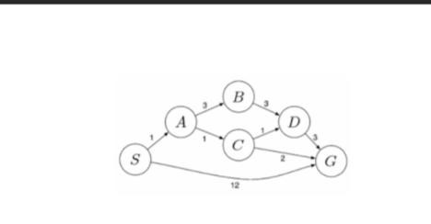

Algorithm
- Insert the start node into the priority queue.
- Remove the node having the lowest path cost.
- If it is the goal node, stop.
- Expand the node.
- Add all neighboring nodes with cumulative cost.
- Repeat until the goal node is reached.
Graph

Edges:
S → A = 1
S → G = 12
A → B = 3
- → C = 1
- → D = 3
- → D = 1
- → G = 2
- → G = 3
Possible Paths
Path | Cost
S → G | 12
S → A → B → D → G | 1 + 3 + 3 + 3 = 10
S → A → C → D → G | 1 + 1 + 1 + 3 = 6
S → A → C → G | 1 + 1 + 2 = 4

Working of UCS
Initially, the search starts from node S.
From S, two paths are available:
- S → A (Cost = 1)
- S → G (Cost = 12)
Since UCS always chooses the path with the lowest cumulative cost, node A is selected.
From A, two new paths are generated:
- S → A → B (Cost = 4)
- S → A → C (Cost = 2)
Again, UCS selects the minimum-cost path, so node C is expanded.
From C, two paths are generated:
- S → A → C → D (Cost = 3)
- S → A → C → G (Cost = 4)
The goal node G is now reached with a total cost of 4, which is smaller than all other possible paths.
Therefore, UCS stops because it has found the least-cost path.
Least-Cost Path
S → A → C → G
Total Cost
Cost = 1 + 1 + 2 = 4

Conclusion
Uniform Cost Search expands nodes in increasing order of path cost. It guarantees the optimal solution when all edge costs are positive. In the given delivery network, the least-cost path from S to G is:
S → A → C → G

Minimum Cost = 4

